Exercise on Ontology Development 101

This exercise aims to create a knowledge base through the Ontology Development 101. Figure 1 deptics the 6 phases of the methodology. In the following section, the first phase «Determine the domain and scope of the ontology» is already given. Complete the remaining phases.

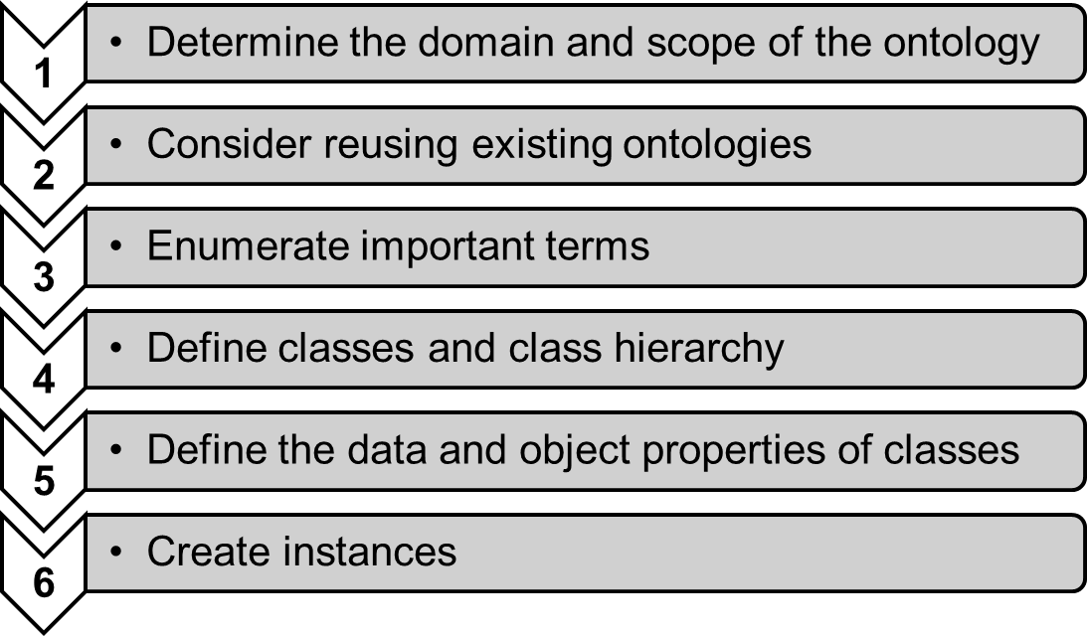
Figure 1. Phases of the methodology Ontology Development 101

- Determine the domain and scope of the ontology

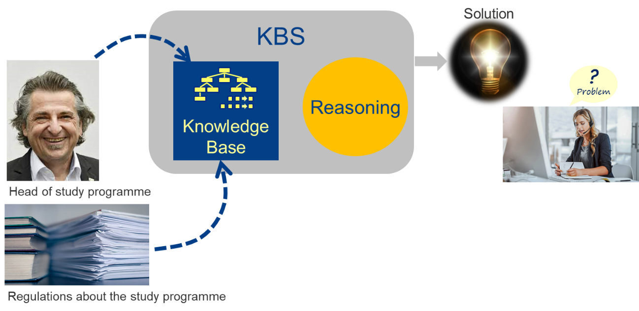

We want to represent knowledge about
  - the courses in the MSc in Business Information Systems,
  - responsibilies for and contribution to these courses.

Constraints from the underlying reality:
  - A module consists of a project or a course.
  - Members of the research staff can be involved in modules of the MSc BIS, he or she can teach a course but can’t coordinate them.
  - A lecturer or professor are part of the didactic staff and can coordinate a module in the MSc BIS.
  - Both research and didactic staff are considered academic staff.

Competency Questions:
    - Who is coordinating course X?
    - Which lecture is taught by Y?
    - When does course X start?
    - Who is researcher involved in course X?
    - What’s the module that consists of only a project?

- Consider reusing existing ontologies
…

- Enumerate important terms
….

- Define classes and class hierarchy
….

- Define the data and object properties of classes
…..

- Create instances
….

