University of Camerino –  Master Degree in Computer Science  Business Process Management and Flexibility | Name:_ ________________________________  Surname:________________________________  Personal Identification Number: ____________  e-mail: ________________________________

Question 1 (3 points) - Business process models undergo a certain lifecycle. Draw this lifecycle and discuss each activity in short.

Question 2 (3 points) - Which roles in the organization are involved in the activities of BP life-cycle?

Question 3 (3 points) – What is the difference between the patterns Multiple Instances with a priori design time knowledge and Multiple Instances with a priori run time knowledge? Is there any correlation with Multiple Instances without a priori run time knowledge?

Question 4 (3 points) - Consider the following BPMN elements: 1. Sequence flow; 2. Data object; 3. Pool; 4. AND-gateway; 5. Looped sub-process; 6. XOR-gateway; 7. Transaction; 8. Directed association; 9. Message event; 10. Message flow; 11. Timer event.
Consider the following process dimensions: A. Control flow / ordering constraints; B. Data flow; 3. Organization and 4. Message flow / cross-organizational interaction
Decide for each construct which process dimension it belongs to!

Question 5 (7 points) – A given model describes steps to open a bank account.
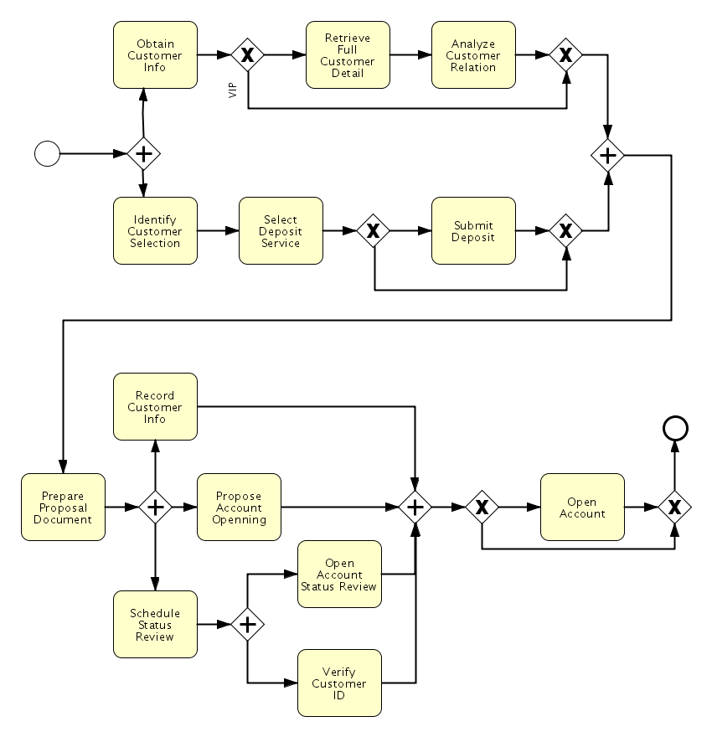
Questions
- Does “Verify Customer ID” always happen after “Record Customer Info”?
- Does “Schedule Status Review” happen in any case?
- How many tasks are executed at least / at most?
- How many tasks can happen between “Schedule Status Review” and “Open Account”?

Question 6 (7 points) - Visualize this business process using BPMN.
A small company manufactures customized bicycles. Whenever the sales department receives an order, a new process instance is created. A member of the sales department can then reject or accept the order for a customized bike. In the former case, the process instance is finished. In the latter case, the storehouse and the engineering department are informed. The storehouse immediately processes the part list of the order and checks the required quantity of each part. If the part is available in-house, it is reserved. If it is not available, it is back-ordered. This procedure is repeated for each item on the part list. In the meantime, the engineering department prepares everything for the assembling of the ordered bicycle. If the storehouse has successfully reserved or back-ordered every item of the part list and the preparation activity has finished, the engineering department assembles the bicycle. Afterwards, the sales department ships the bicycle to the customer and finishes the process instance.
Visualize this business process using BPMN.

Question 7 (7 points)
- Which modeling errors can you detect in the process model depicted in the following?
- Considering just the control flow the student has to map the process model into petri-net

