Case Study: Facility Security at the Beta Corporation

Beta Corporation is a small manufacturer and distributor of tools for industrial markets. Recent incidents have left Acme executives concerned about the physical security of their headquarters, factory and warehouse

Stakeholder View Exercise
- A competitor’s product is based on Acme trade secrets. Projected loss to Acme is $400,000 US in sales.
- Tools were stolen from the Acme factory four times in the last year. Replacement cost and lost productivity totaled $75,000.
- Unauthorized individuals were found in company facilities three times in the last year. Police found no evidence of break-ins.
- The CFO is therefore concerned about security of company property
- The HR Director is therefore concerned about safety of company staff
- The CEO shares both concerns
- All three leaders share a two-part goal to improve security at Acme facilities – Prevent unauthorized access to Acme facilities – Track all access to Acme facilities

Requirements Realization View Exercise
- The following requirements will improve security at Acme facilities
  - Ensure that everyone who enters the facility is a employee, contractor or authorized visitor
  - Enable employees to improve workplace security through daily practices
  - Capture video of all facility entries and exits
- The requirements will be realized by components of a Facility Access Control product with Keycard Badge Access, Employee Training, Video Recording and Facility Access Policy

Organization View Exercise
Acme Corporation has three locations, each of which houses a key internal organization
- The Headquarters houses Corporate Management, which includes the CEO, CFO and HR Director.
- The Distribution Center houses the Warehousing and Distribution organization
- The Factory houses the Manufacturing Organization

Business Process View Exercise
The Keycard Badge Lifecycle business process:
- Realizes the Keycard Badge Access business service
- Is composed of three successive sub-processes, each of which is performed by a specific role, and uses specific application services
  - Keycard Badge Provisioning: Performed by Receptionist and Uses Generate Key Badge and Assign Temporary Key Badge
  - Keycard Badge Usage: Performed by Facility User and Uses Process Access Request
  - Keycard Badge Deprovisioning: Performed by Receptionist and Uses Invalidate Keycard Badge and Remove Temporary Keycard Badge Assignment

Case Study: Facility Security at the Beta Corporation

Beta Corporation is a small manufacturer and distributor of tools for industrial markets. Recent incidents have left Acme executives concerned about the physical security of their headquarters, factory and warehouse

Stakeholder View Exercise
- A competitor’s product is based on Acme trade secrets. Projected loss to Acme is $400,000 US in sales.
- Tools were stolen from the Acme factory four times in the last year. Replacement cost and lost productivity totaled $75,000.
- Unauthorized individuals were found in company facilities three times in the last year. Police found no evidence of break-ins.
- The CFO is therefore concerned about security of company property
- The HR Director is therefore concerned about safety of company staff
- The CEO shares both concerns
- All three leaders share a two-part goal to improve security at Acme facilities – Prevent unauthorized access to Acme facilities – Track all access to Acme facilities

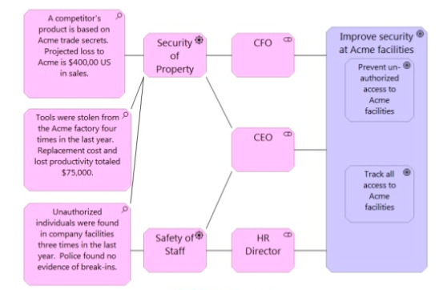

Requirements Realization View Exercise
- The following requirements will improve security at Acme facilities
  - Ensure that everyone who enters the facility is a employee, contractor or authorized visitor
  - Enable employees to improve workplace security through daily practices
  - Capture video of all facility entries and exits
- The requirements will be realized by components of a Facility Access Control product with
  - Keycard Badge Access
  - Employee Training
  - Video Recording
  - Facility Access Policy

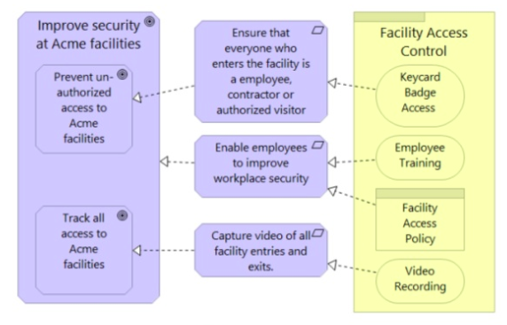

Organization View Exercise
Acme Corporation has three locations, each of which houses a key internal organization
- The Headquarters houses Corporate Management, which includes the CEO, CFO and HR Director.
- The Distribution Center houses the Warehousing and Distribution organization
- The Factory houses the Manufacturing Organization
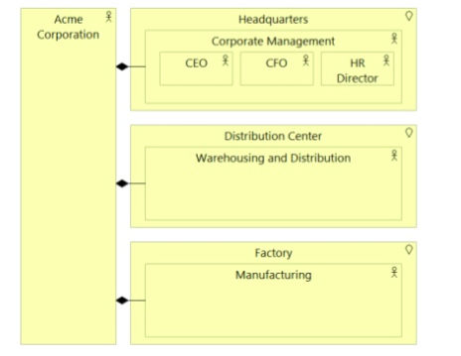

Business Process View Exercise
The Keycard Badge Lifecycle business process:
- Realizes the Keycard Badge Access business service
- Is composed of three successive sub-processes, each of which is performed by a specific role, and uses specific application services
  - Keycard Badge Provisioning: Performed by Receptionist and Uses Generate Key Badge and Assign Temporary Key Badge
  - Keycard Badge Usage: Performed by Facility User and Uses Process Access Request
  - Keycard Badge Deprovisioning: Performed by Receptionist and Uses Invalidate Keycard Badge and Remove Temporary Keycard Badge Assignment

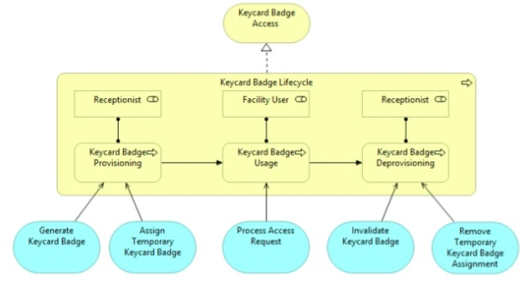

SOURCE
https://www.slideshare.net/iverband/an-introduction-to-enterprise-architecture-visual-modeling-with-the-archimate-21-language-51680779

